**Install and create Vue.js**

* Vue.js requires Node.js. Download and install it from the official Node.js website.
* Install Vue CLI globally using npm:

npm install -g @vue/cli

* Navigate to the directory where you want to create the project and Create a new Vue.js project:
* vue create surveyproject
* Navigate into your project folder
* Install dependencies
* npm install
* npm run serve

**Creating a Vue Project (Frontend)**

* We created a SurveyProject project, a web application allowing us to create, read, update, and delete surveys.
* It is built with Vue.js for the frontend and have the following components in index.js
  + CreateSurvey.vue
  + DeleteSurvey.vue
  + HomePage.vue
  + ReadSurvey.vue
  + UpdateSurvey.vue

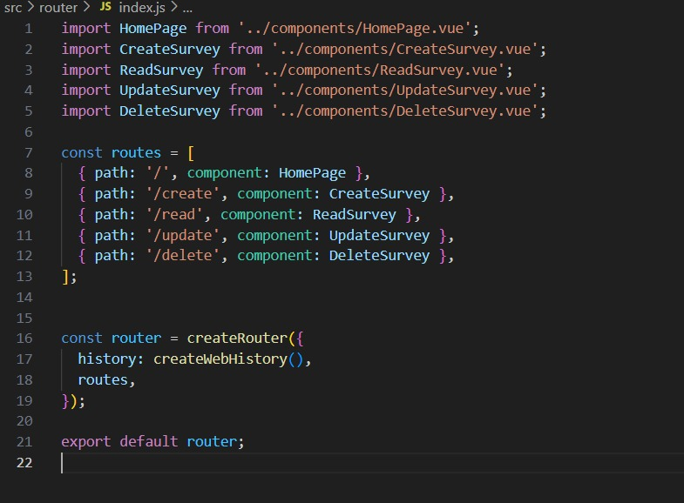

* **HomePage.vue** defines a Survey Management home page that provides navigation to different pages for managing surveys (Create, Read, Update, and Delete)
* **CreateSurvey.vue** is used to create a survey form, collecting user input, and submitting the data to a backend server.
* It includes input fields for survey details like First name, Last name, Address, city, state, zip code, phone number, email id, date, and a few campus feedback, and recommendations.
* **ReadSurvey.vue** is used for fetching and displaying survey data based on an email address from the data we entered in CreateSurvey.vue
* **UpdateSurvey.vue** is used for fetching and updating survey details based on a user-provided email address.
* **DeleteSurvey.vue** is used for fetching and deleting survey details based on a user-provided email address

**Create a Springboot Project**

* Go to the spring initializer
* Configure the project by selecting the project type as Maven, the language as Java, and the latest stable version of Spring Boot.
* Enter a unique identifier for the group and specify the name of our project.
* Select Java version
* Add dependencies- Spring Web, Spring Data JPA, MySQL Driver, Spring Boot DevTools, Lombok
* Click "Generate" to download the project as a .zip file

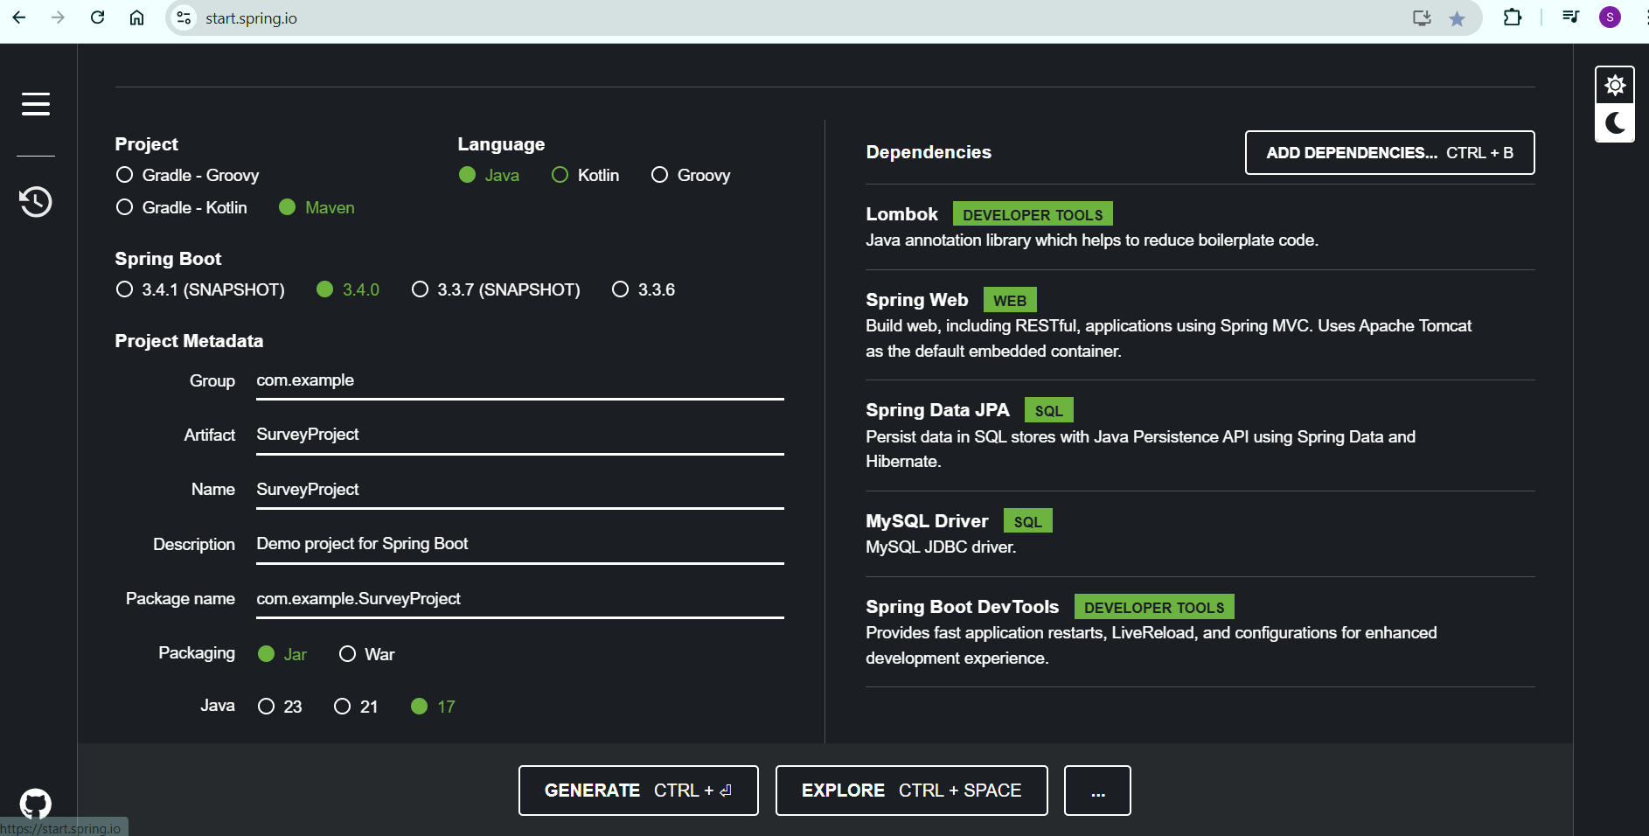

* Extract the .zip file.
* Import the project into IntelliJ IDEA
* We used a Controller, service, repository, model, and configuration.
* **SurveyController** handles HTTP requests for CRUD operations.
* **SurveyService** contains business logic for managing surveys.
* **surveyRepository** interacts with the database using Hibernate
* **SurveyResponse** represents the survey data scheme
* **Application.properties** configures server port, database URL and Hibernate properties.

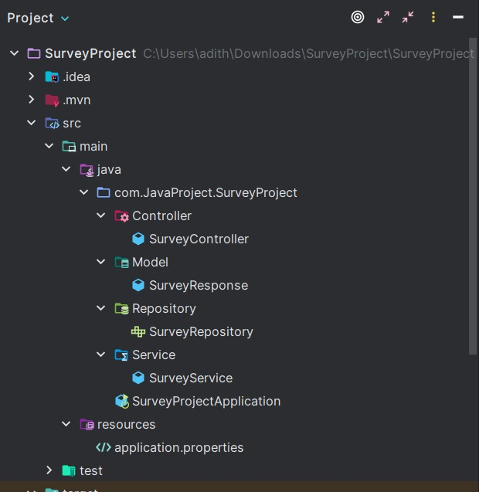

**Connect to database:**

Create a MySQL database and update the application.properties with the MySQL username and password

**Run the Project**

* Go to the path of surveyproject. We will start the server by using the command –

npm run serve

* Run the surveyproject application.
* We can access the backend on port 8099 (http://localhost:8099) and the frontend runs on port 8080 (<http://localhost:8080>).

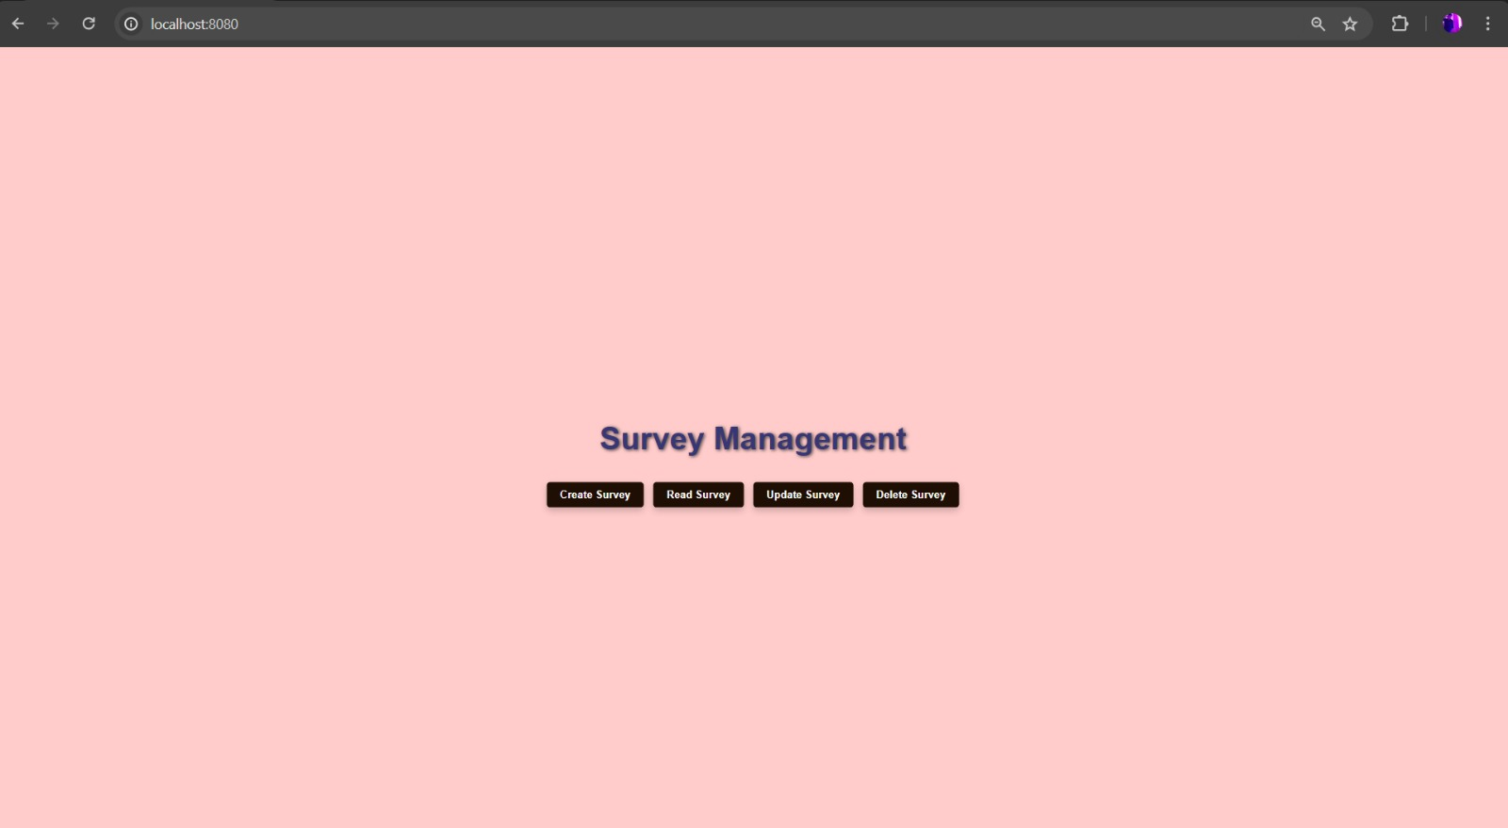

**Team members:**

* Adithya Reddy – G01460466
* Sravya Kotwal – G01454156
* Keerthana Reddy – G01461198
* Saranya Chakravarthy Korrapati – G01471987
* Akhil Nakka - G01411969
* Samuel Archit Sowpathi – G01448337
* Balaji Ganesan - G01417844
* Greeshma Koneru - G01434318
* Nohith Challa - G01463765